**POWER BI ASSIGNMENT-11**

**Use Case –** House Price

**Source –** House Price

**Analytic –** Clean & Secure the Report

Q1. Open the excel file in the above folder and create a basic table showing data for sales of houses in different areas

**Step-1.**

The dataset for this assignment is House price.xlsx which is in excel format and we can load the data set into Power Bi application using Get Data🡪Excel option as shown below

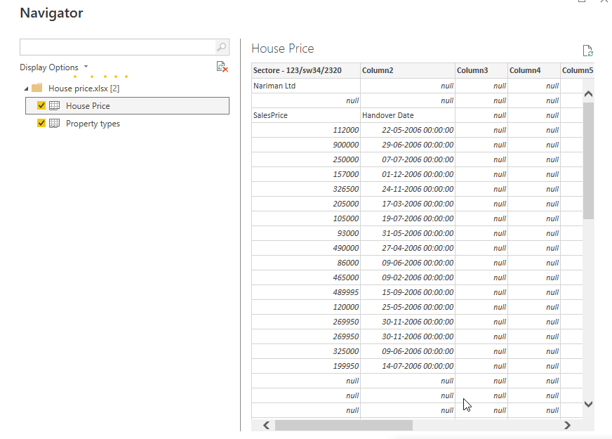

As we can see there are two excel sheet available in the dataset. One is “House price” and other is “Property types”. Also in house price table, we can see many null value available in rows and columns and it need to be cleaned and formatted properly to make any visual. Hence we can go ahead with “Transform” option rather than “load” to do all preprocessing steps and make to align the data in a structured way.

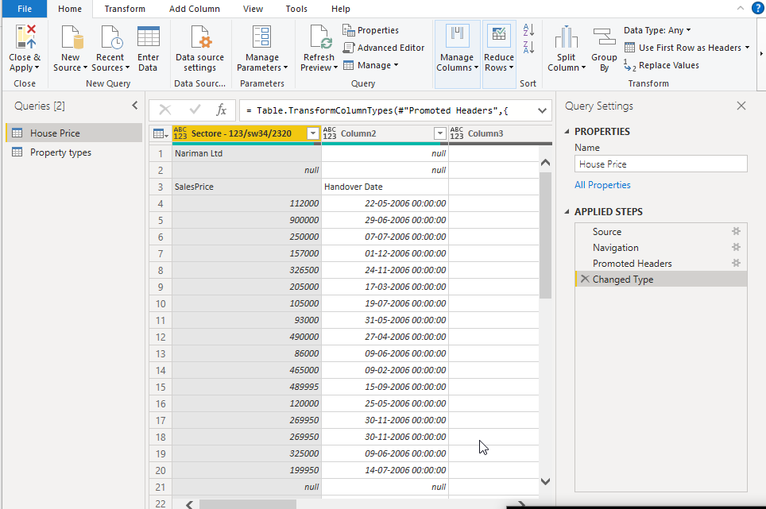

The dataset does not contain proper columns name and the first two rows are complete null values and hence we should remove first two rows Home🡪 Remove Rows🡪 Remove Top Rows

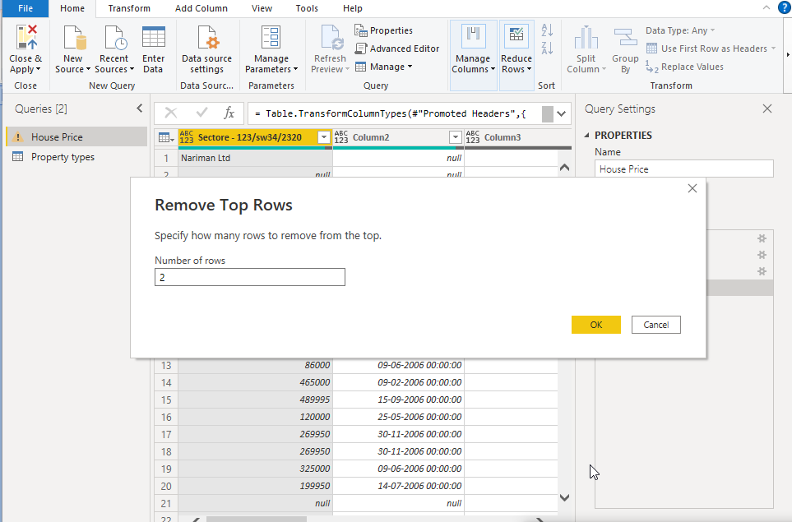

Now the first row contains the header names and we can make them as headers using the below step.

Home🡪Use first row as headers

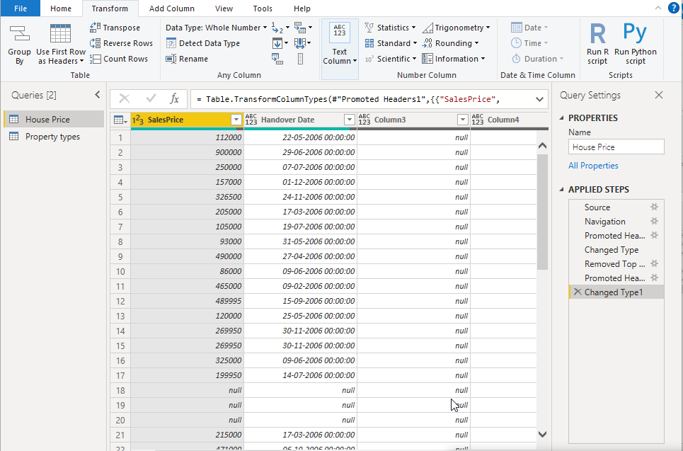

As you can see “Column 3 to Column 5” are complete null values and hence it can be removed from the dataset using “remove column option”. There are some row level null values which does not add any impact to the report and this can be removed using “Remove Blank rows”.

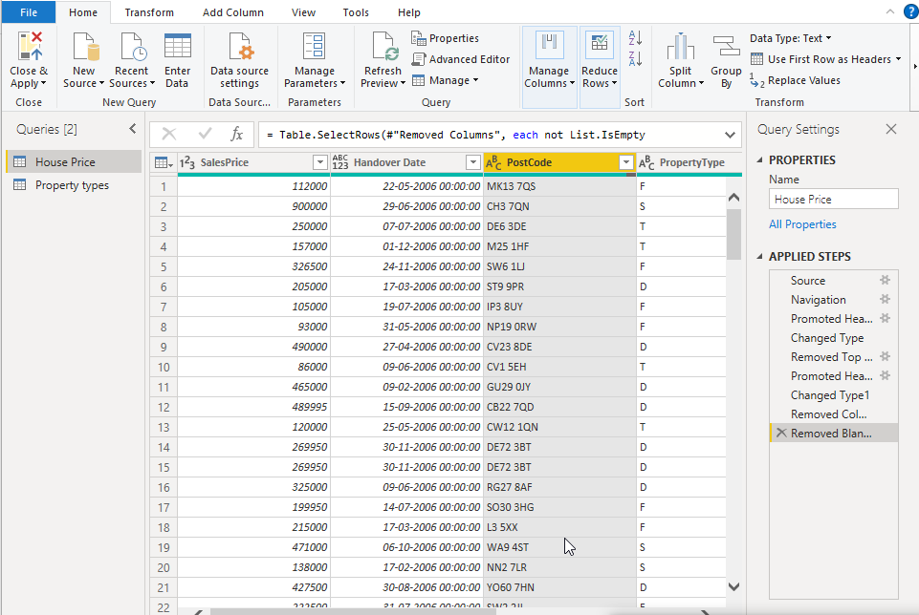

In column “Handover date”, the format of the data type has been changed to “Date”. Upon changing the data, there is a red line popped up just below the column header which show the error. Hence this can be removed using the below step Select “Handover date” column 🡪Remove Rows🡪Remove errors.

In “Property Type” table, the column header are not assigned as shown below

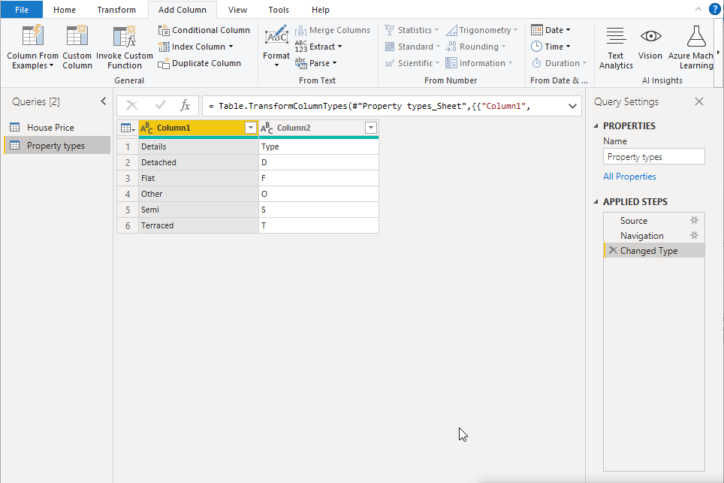

The appropriate column headers are assigned using “Use First Row as Headers” option

Step-2. Next step is to create a relationship between the two table “House Price” and “Property type”. Go to model view and there we can see the schema of the two tables. There is property type is common between those two tables and the relationship can be created by dragging the type column from one table to another table

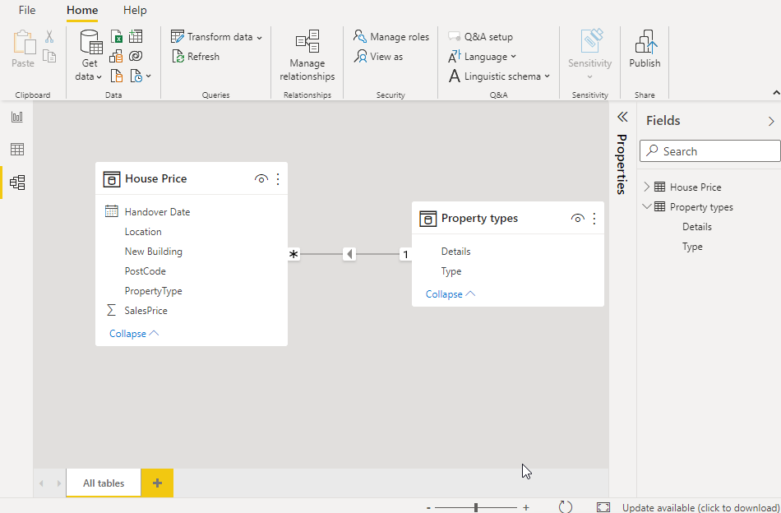

In report view, create a table visual by dragging necessary columns as shown below

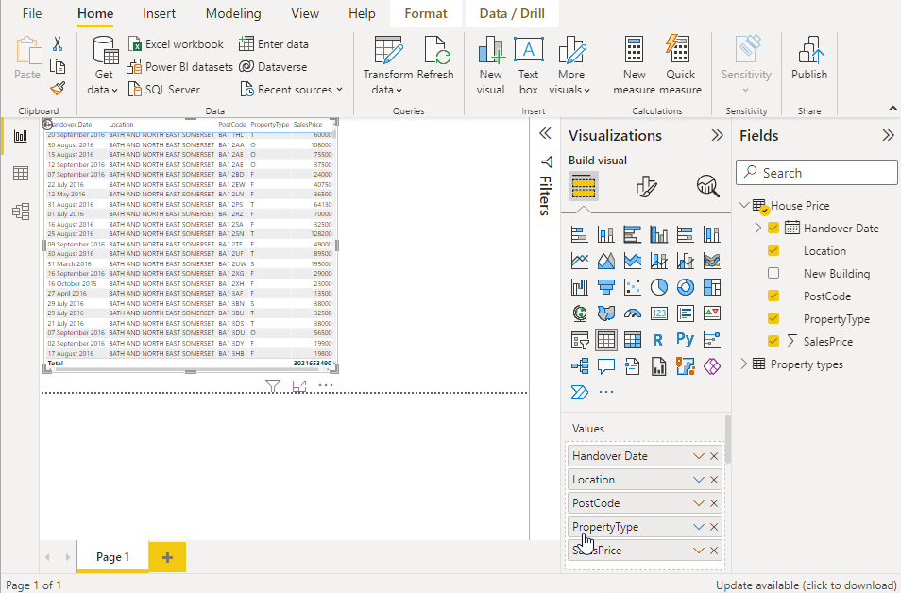

Q2. Create a role for each house type, filtering using the property type code. Look in the property types sheet to find the codes.

Step-3. Now to create role for each house type based on the property type, Go to Model view, Click on manage roles and create roles and type the respective DAX expression for each Property type as shown

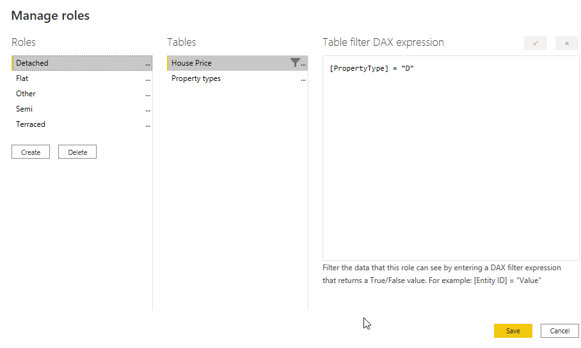

Detached=”D” , Flat = “F”, Other = “O”, Semi = “S”, Terraced = “T”

To check if the created roles are working fine, click on “View as” option under home section in “Model View” as shown below

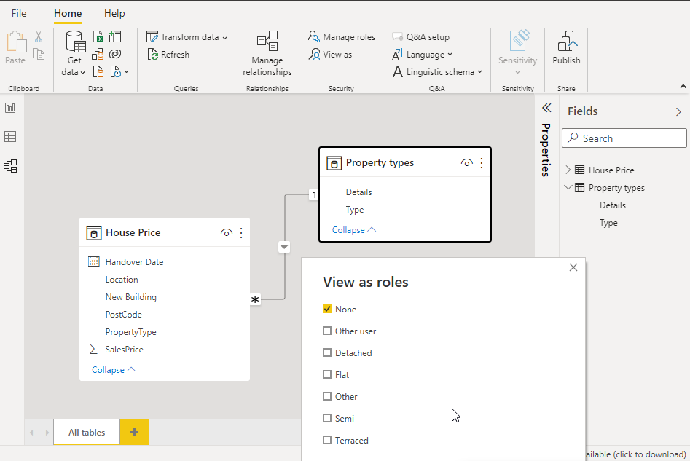

Based on what we select in the check box in view as roles windows, the respective report will be shown. To check, select Flat and the respective reports which contains only “Flat” will be displayed in report view

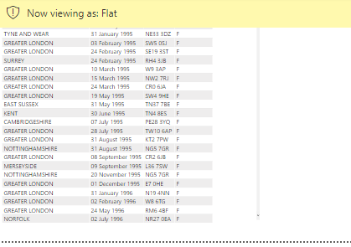

Similarly we can check for Semi and Terraced and the respective reports are shown below

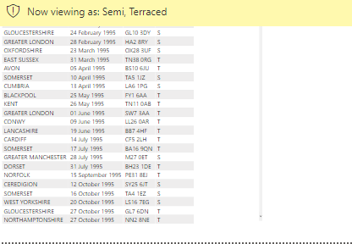

Q3. Publish the report in Power Bi Service and check the roles

Step – 3. To do this task, Save the power bi file and click on “Publish” button under Home section. A new pop up window opens asking to select a destination as shown below

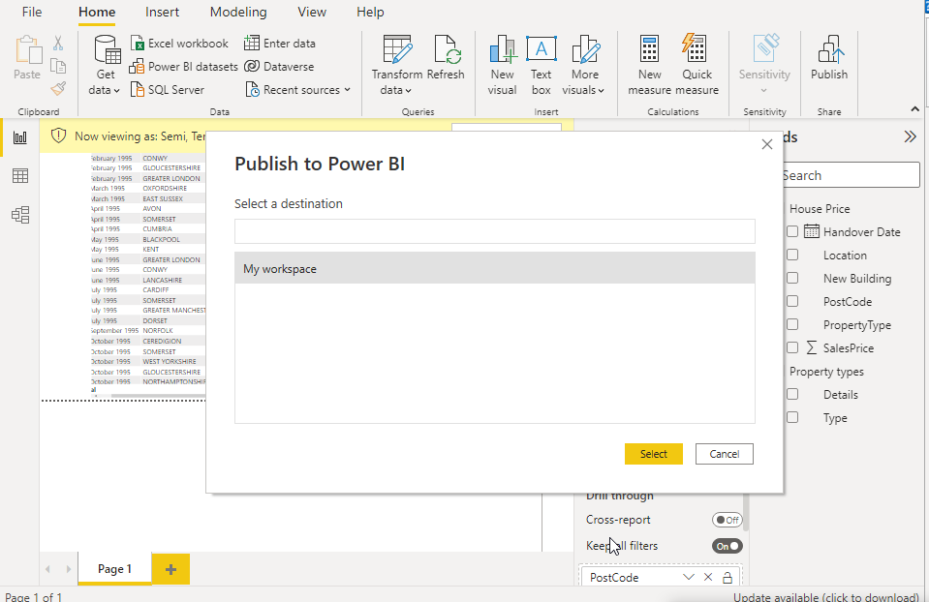

Select the destination as “My Workspace” in this case and click on select. The Report get published to Power Bi Service and the success message gets displayed as shown below

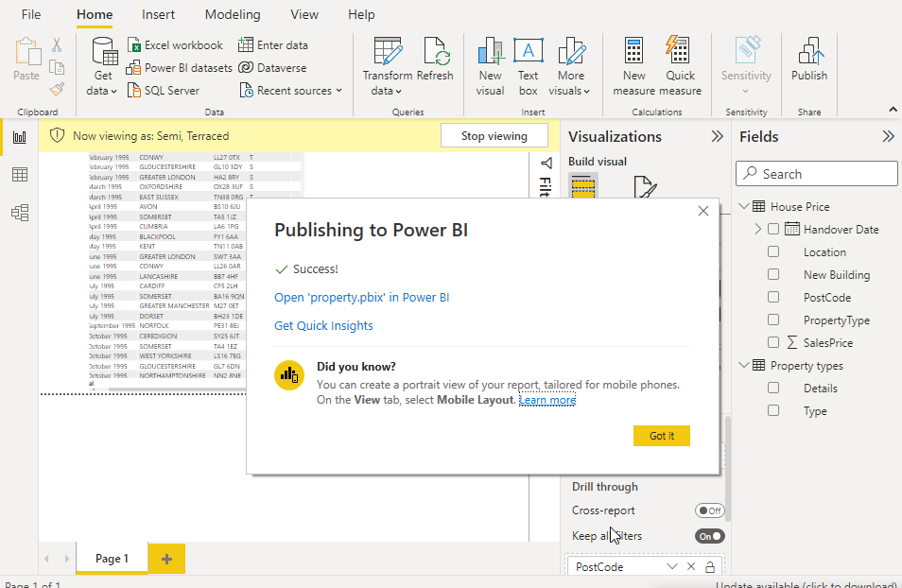

To view the report in Power BI Service, sign in to the app.powerbi.com and the respective report gets displayed as shown below

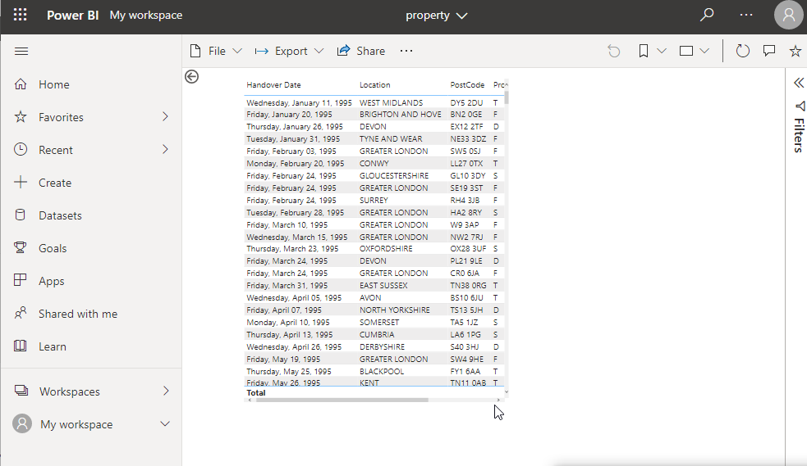

To check if the respective roles are working properly in the Power BI Service, click on my workspace, Select House price and select Security. There is pop-up windows opens asking for row level security where we can provide email address and add the respective users as shown below

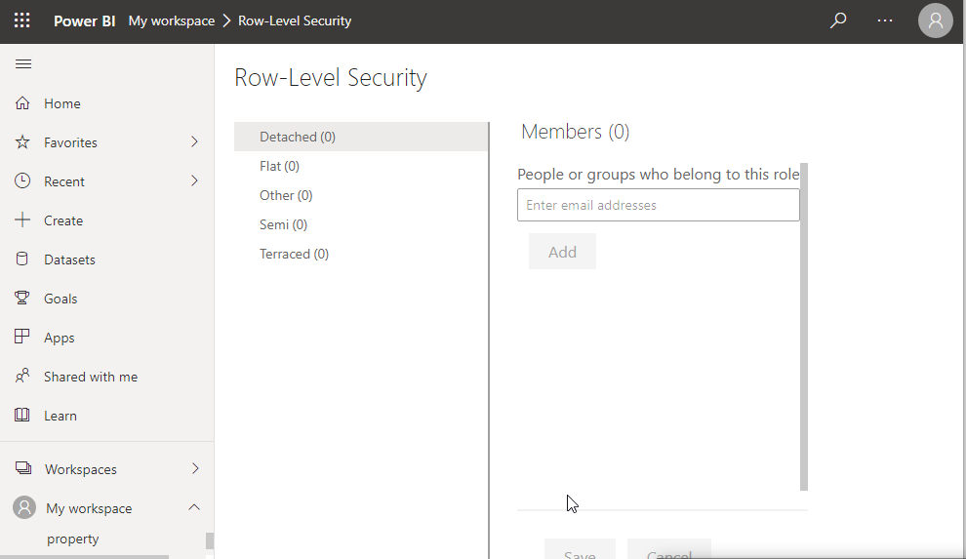

To test the role in Power Bi service, click on 3 dots in row level security and select “Test as role” as show below

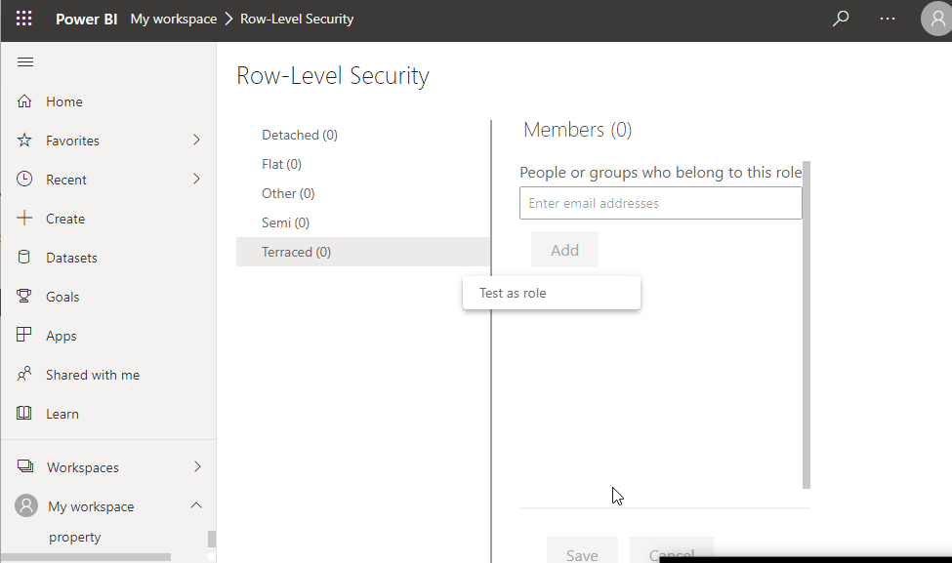

The respective report will be displayed based on the filter as shown below

